Supplementary raw materials (i.e., whole films/membranes) of Western blot.
Bax-15''
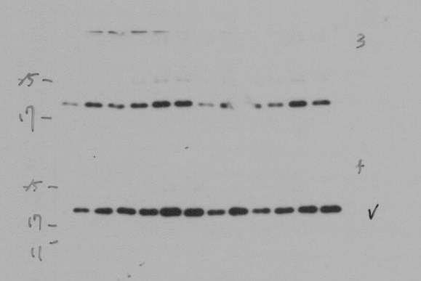
Caspase3, PARP, P-Smad15, P-Smad3-1'
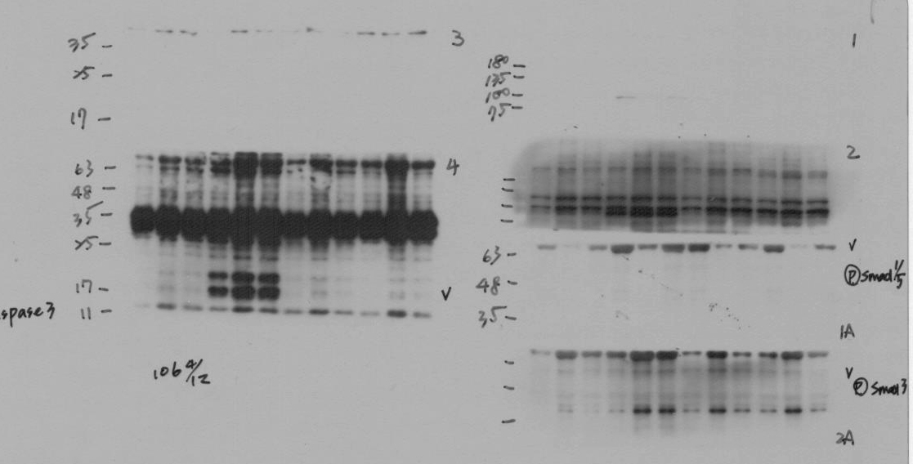
Caspase3, PARP, P-Smad15, P-Smad3-2'
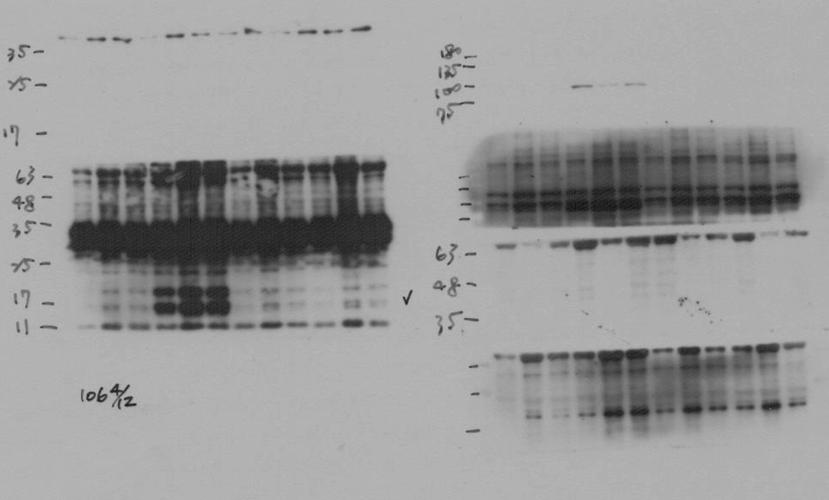
Caspase3, PARP, P-Smad15, P-Smad3-5''
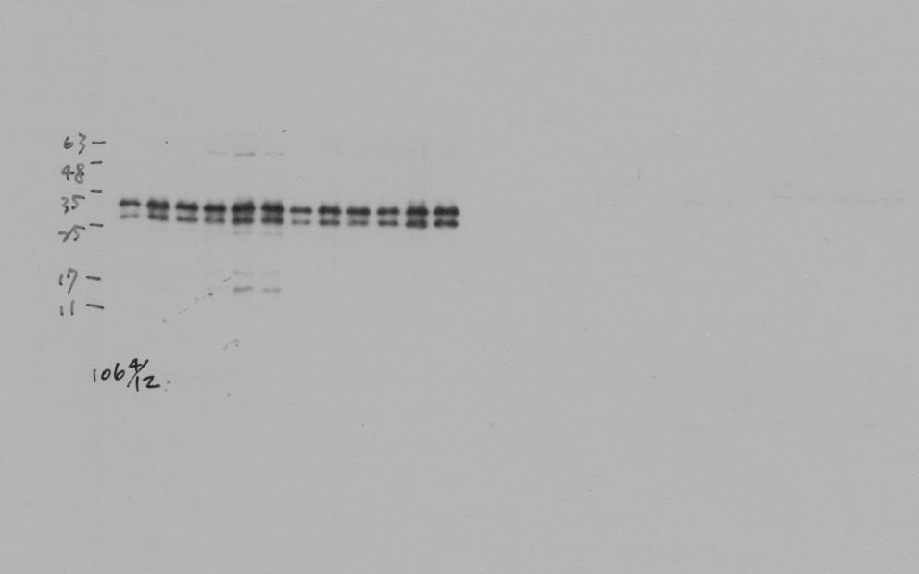
Caspase3, PARP, P-Smad15, P-Smad3-15''

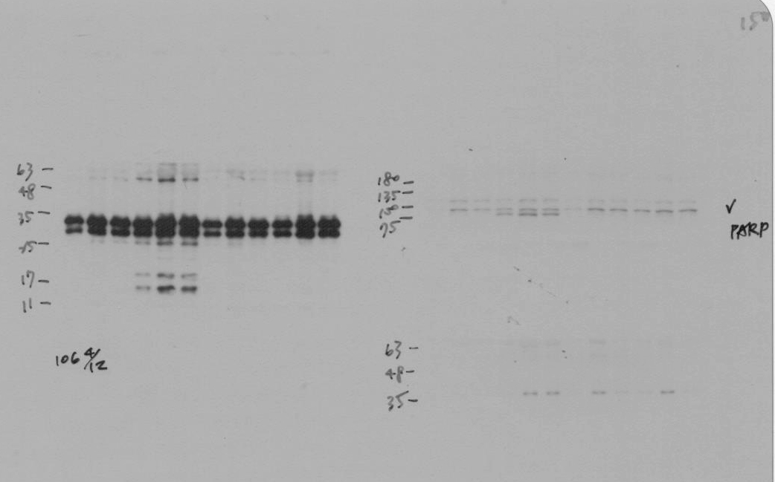
Caspase3, PARP, P-Smad15, P-Smad3-30''
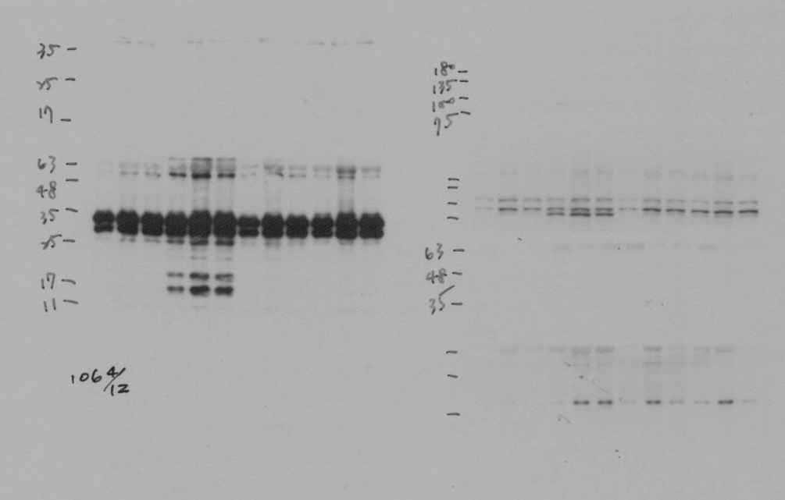
IL6-10'
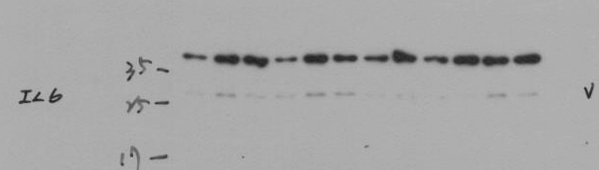
iNOS(135), TRL2(90), IL12(25)-1'-20170907
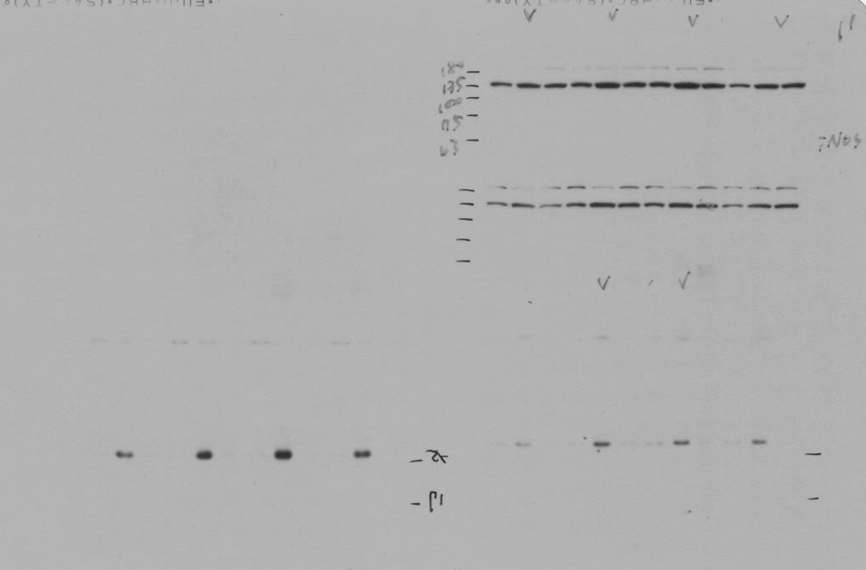
iNOS(135), TRL2(90), IL12(25)-2'-20170907

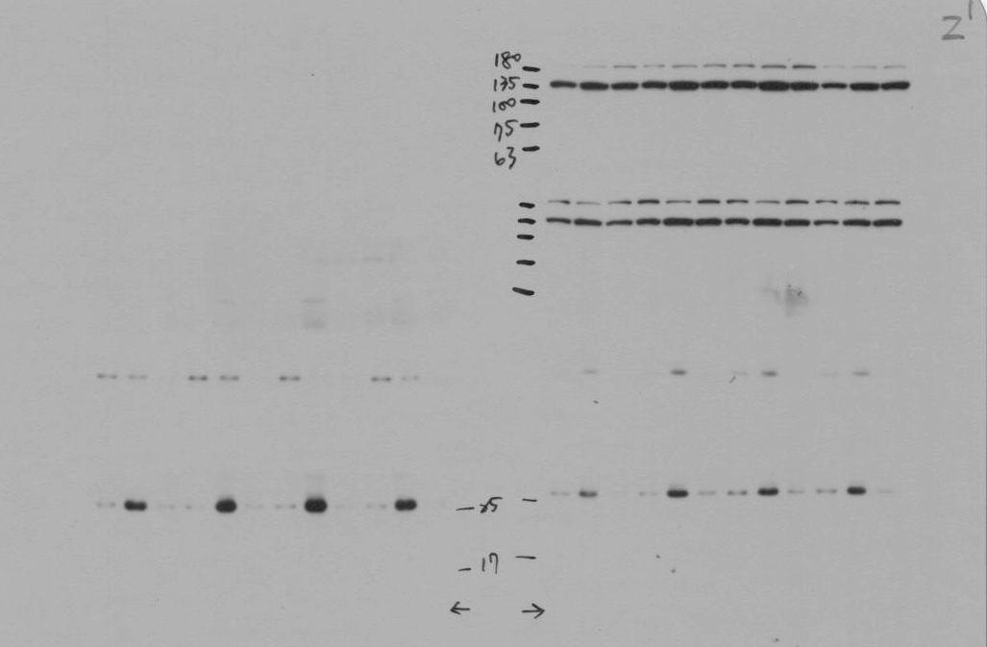
iNOS(135), TRL2(90), IL12(25)-5'-20170907
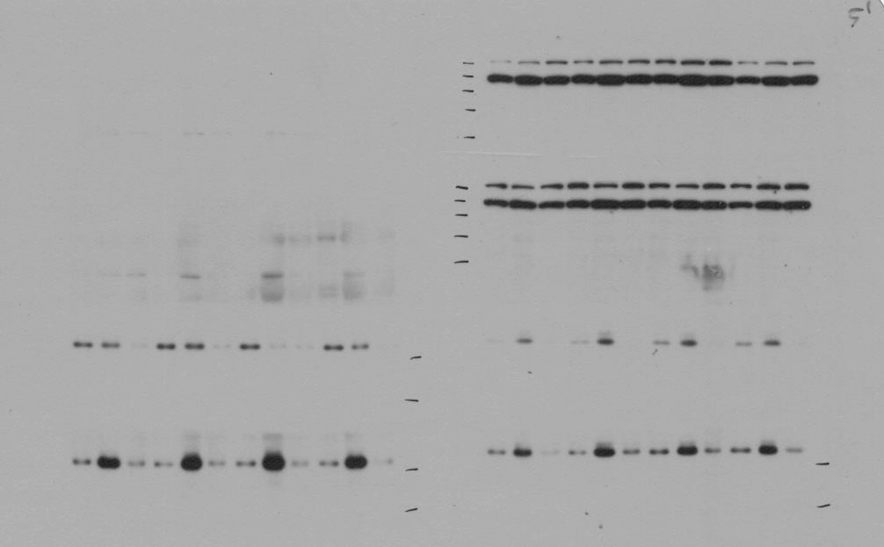
iNOS(135), TRL2(90), IL12(25)-10'-20170907
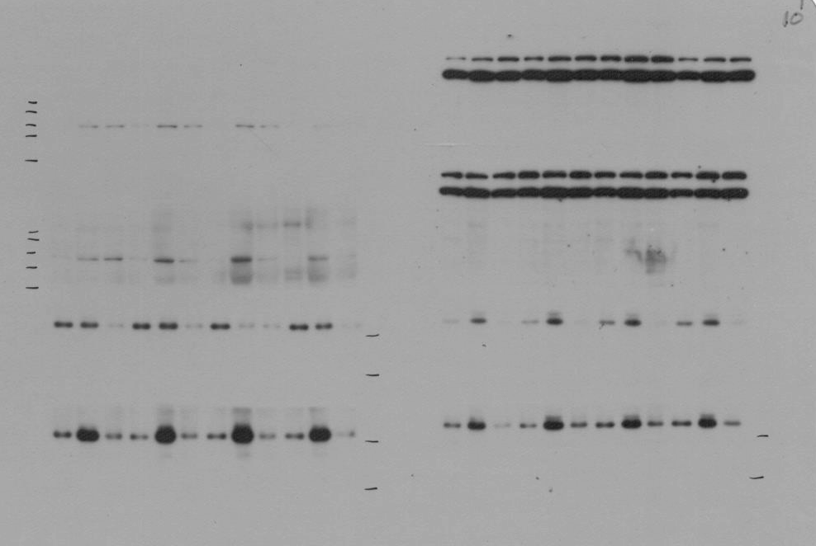
iNOS(135), TRL2(90), IL12(25)-15'-20170907
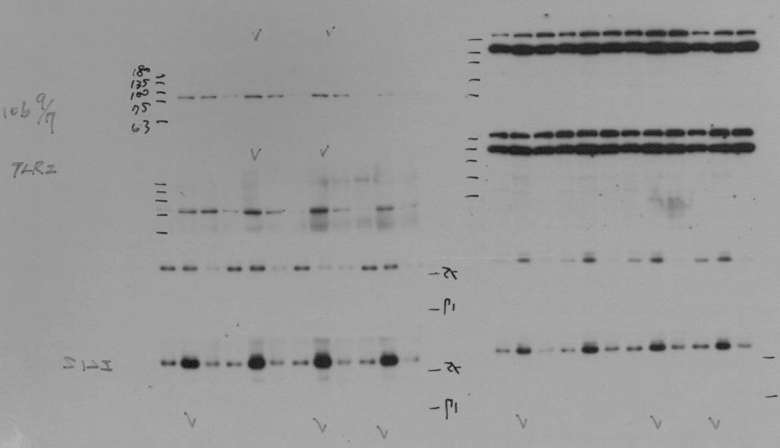
MMP9, TLR4-1' & 2'
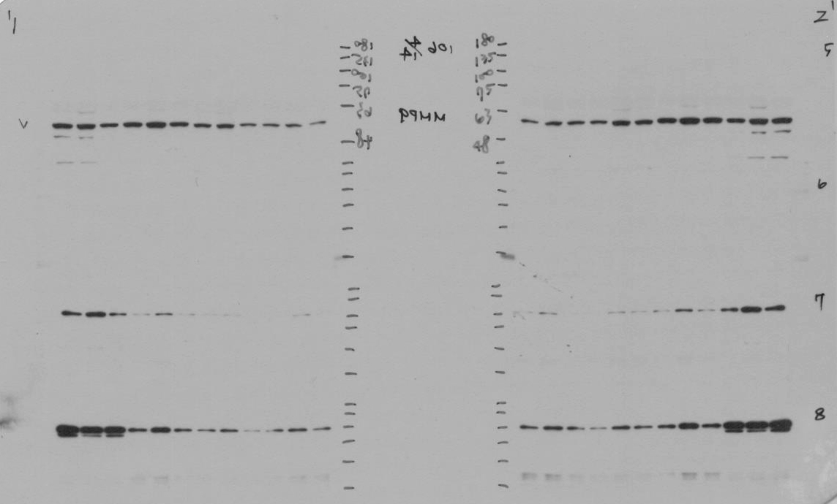
MMP9, TLR4-3' & 4'
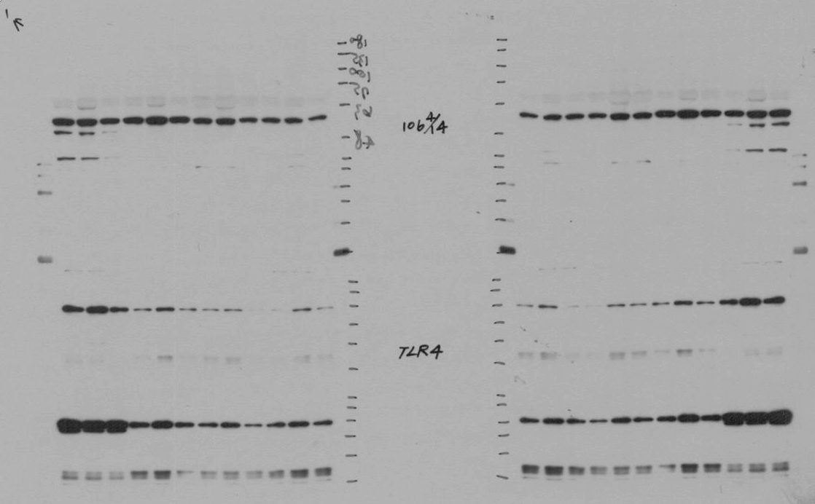
MMP9, TLR4-6' & 8'
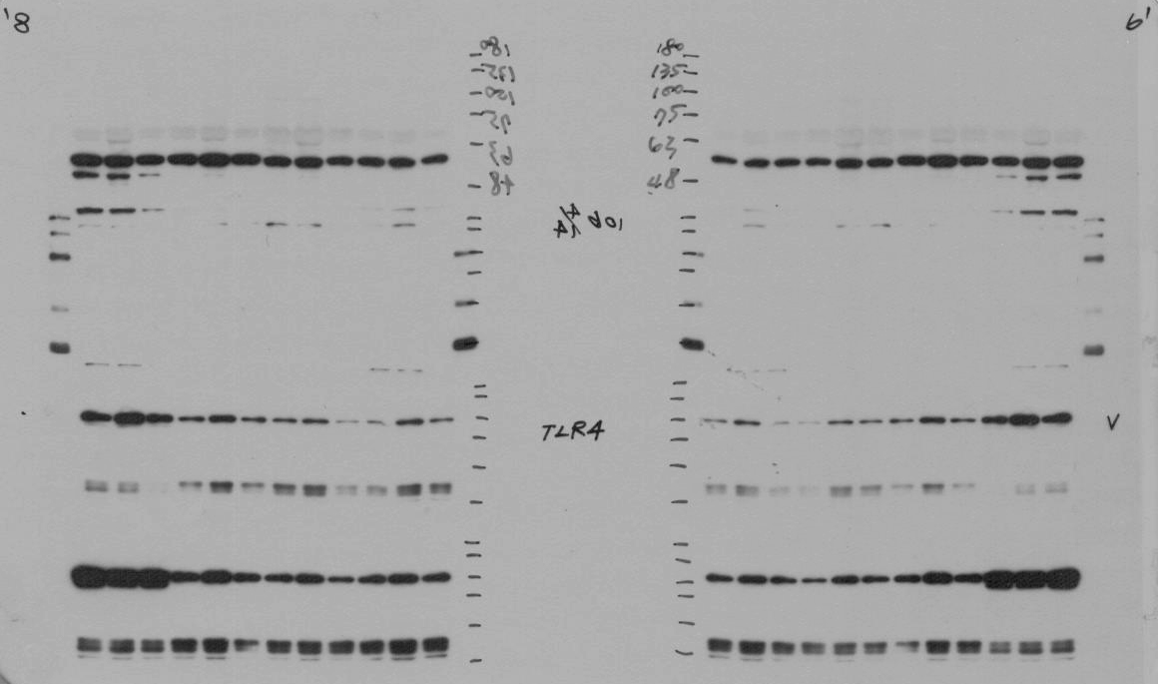
NFkB(65) & BMP2 & PARP-1'
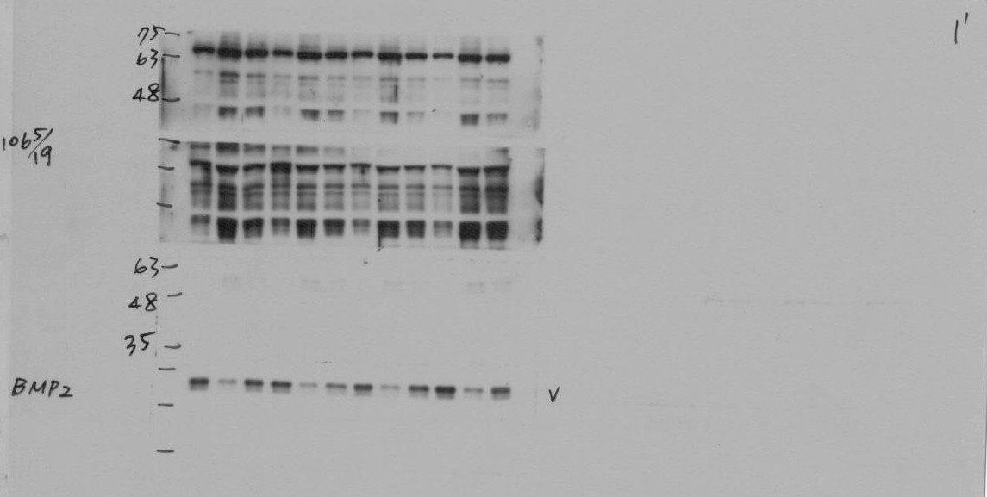
NFkB(65) & BMP2 & PARP-2'
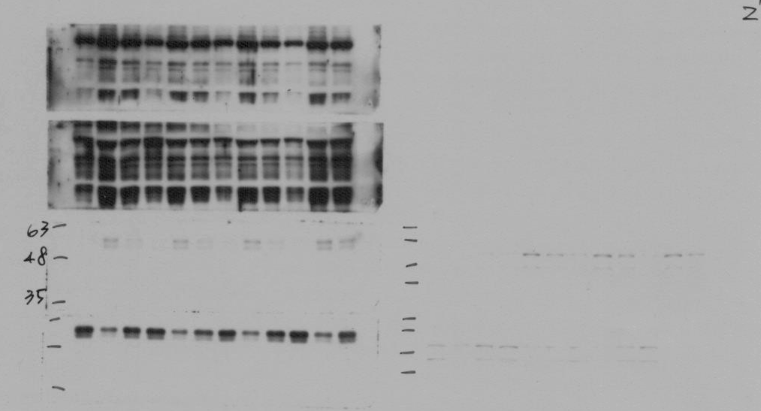
NFkB(65) & BMP2 & PARP-4'
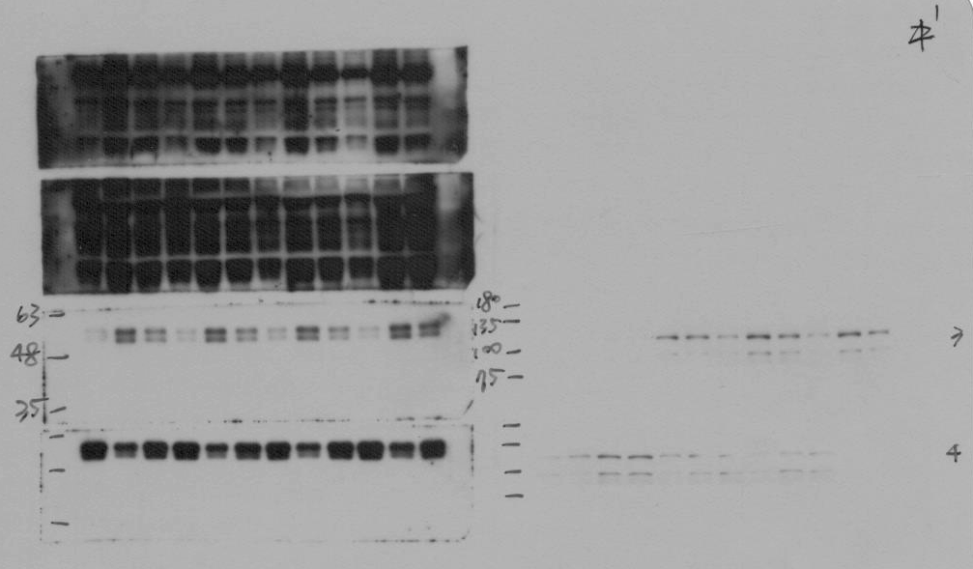
NFkB(65) & BMP2 & PARP-6'
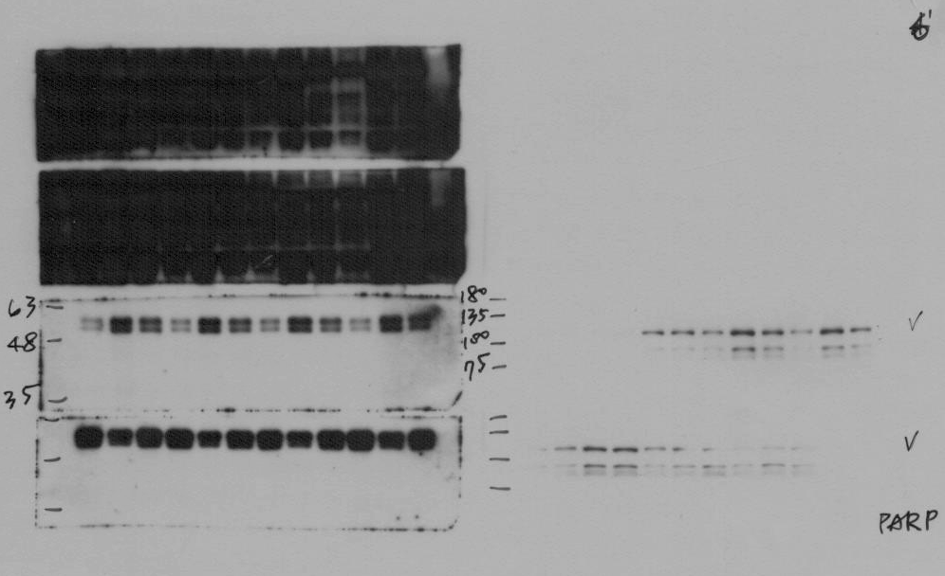
NFkB(65) & BMP2 & PARP-15''
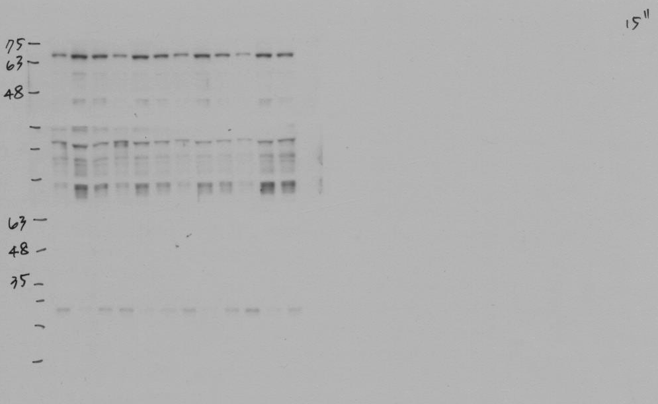
NFkB(65) & BMP2 & PARP-30''
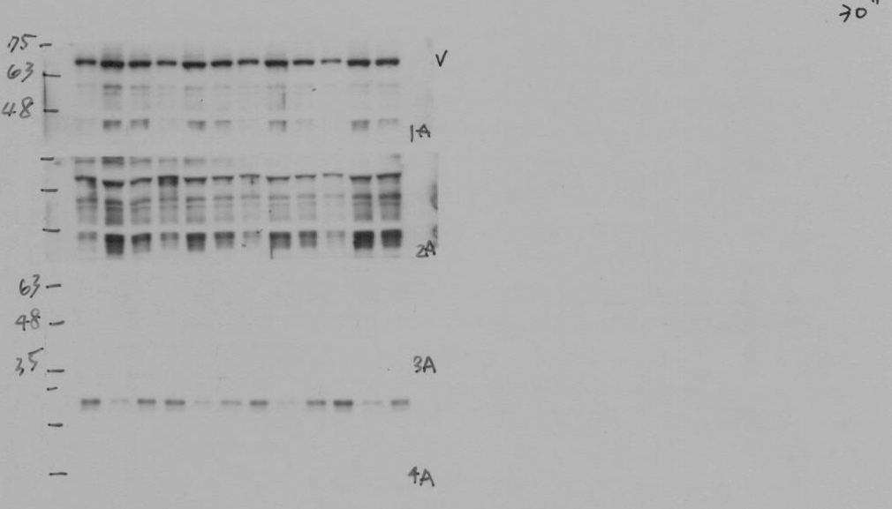
NOX1, NOX2, Actin, COIV-1'
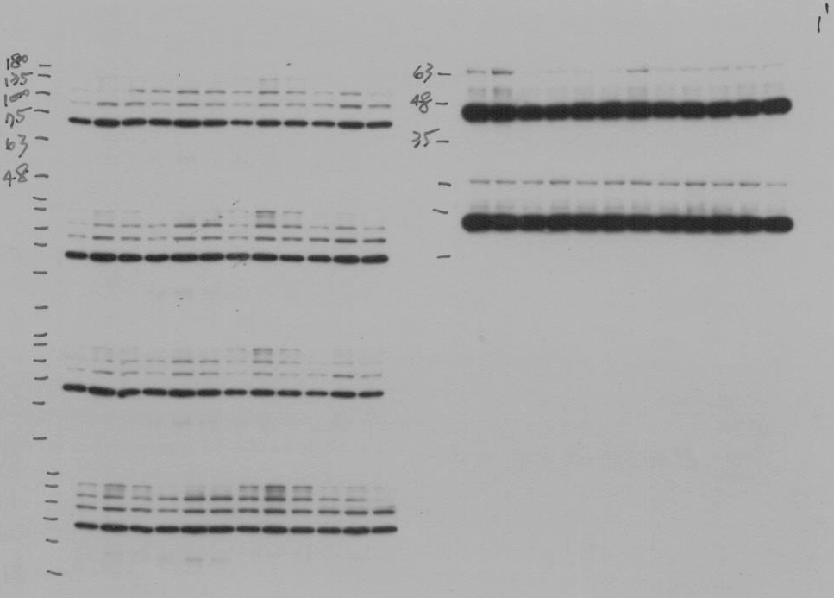
NOX1, NOX2, Actin, COIV-2'
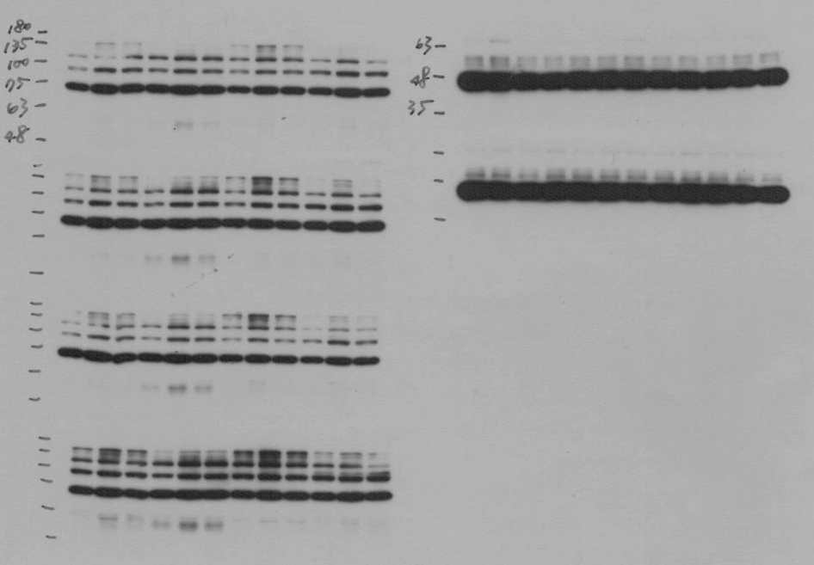
NOX1, NOX2, Actin, COIV-3''
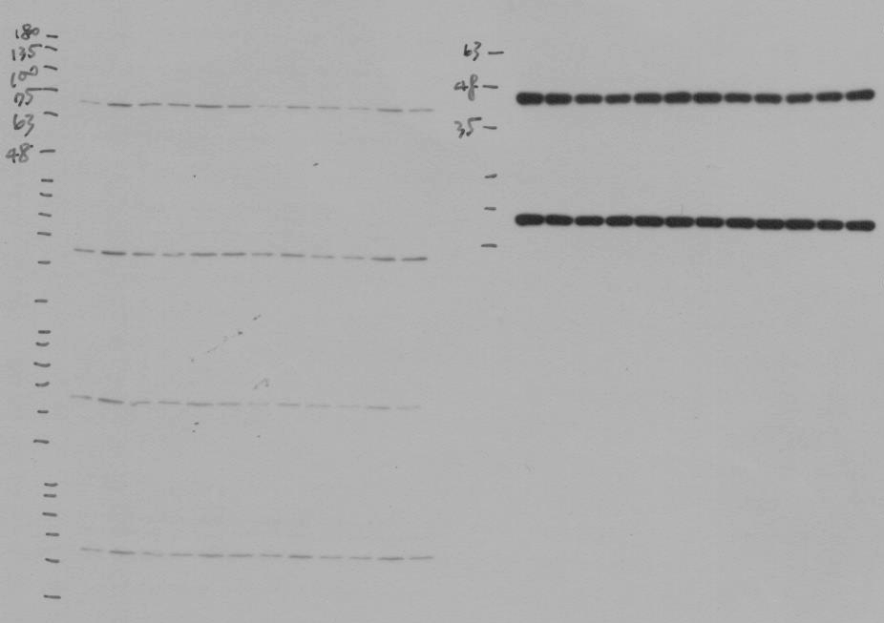
NOX1, NOX2, Actin, COIV-10''
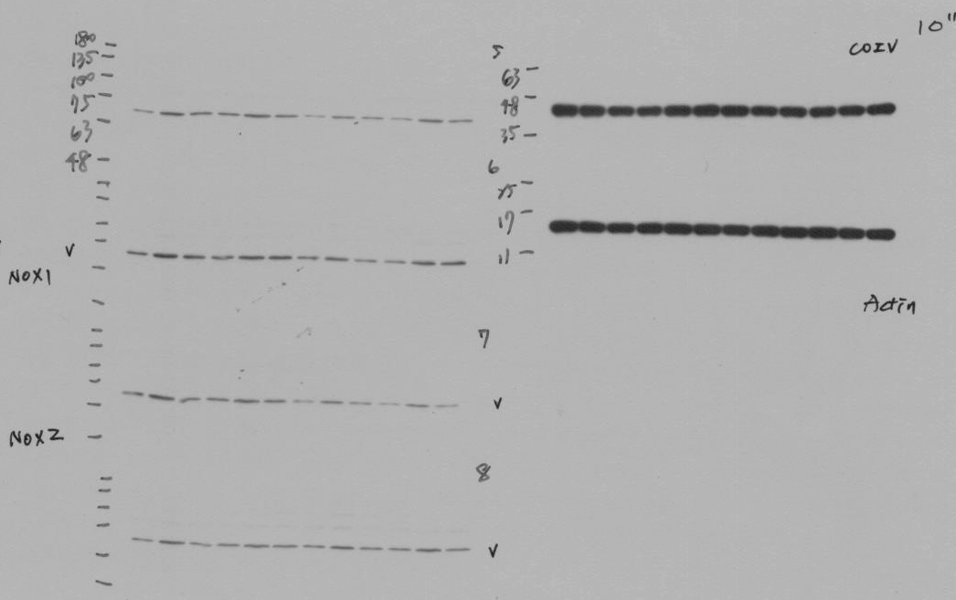
NOX1, NOX2, Actin, COIV-30''
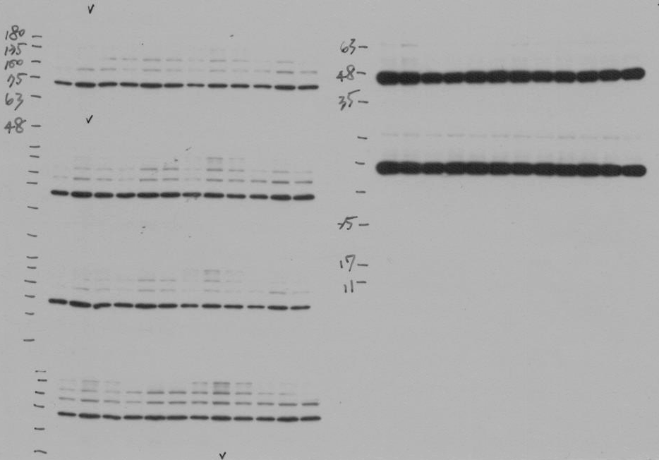
Oxyblot-5''-20170908
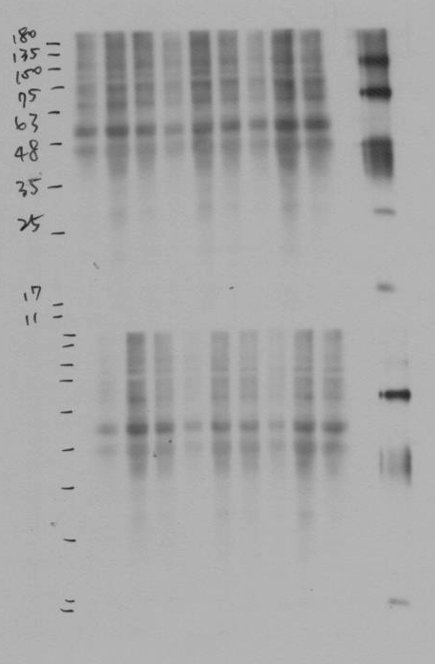
Oxyblot-15''-20170908
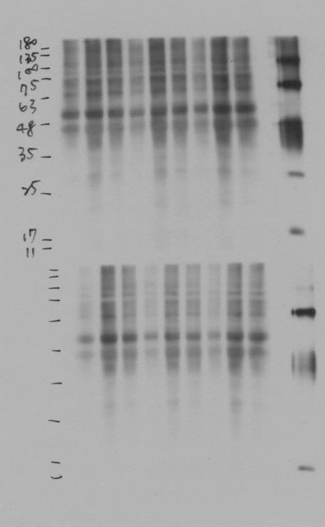
ppt-Actin-RANTES(10) & TNFa(25) & Actin-5''
ppt-Actin01-Actin, TLR4(97), U-10'-20170908
ppt-Actin01-NOX1, NOX2, Actin, COIV-10''
ppt-Actin02-Actin, TLR4(97), U-10'-20170908
ppt-Actin02-NOX1, NOX2, Actin, COIV-10''
ppt-Actin03-NOX1, NOX2, Actin, COIV-10''
ppt-Bax-15''
ppt-BMP2-NFkB(65) & BMP2 & PARP-1'
ppt-BMP2-NFkB(65) & BMP2 & PARP-2'
ppt-Caspase3-Caspase3, PARP, P-Smad15, P-Smad3-2'
ppt-COIV-NOX1, NOX2, Actin, COIV-10''
ppt-DNP st. -Oxyblot-5''-20170908
ppt-IL6-10'
ppt-IL12-iNOS(135), TRL2(90), IL12(25)-10'-20170907
ppt-iNOS-iNOS(135), TRL2(90), IL12(25)-1'-20170907
ppt-MMP9-MMP9, TLR4-1' & 2'
ppt-NFkB-NFkB(65) & BMP2 & PARP-30''
ppt-NOX1-NOX1, NOX2, Actin, COIV-30''
ppt-NOX2-NOX1, NOX2, Actin, COIV-2'
ppt-Oxyblot-5''-20170908
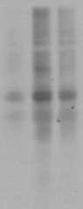
ppt-P-Smad3-Caspase3, PARP, P-Smad15, P-Smad3-2'
ppt-P-Smad15-Caspase3, PARP, P-Smad15, P-Smad3-2'
ppt-PARP-NFkB(65) & BMP2 & PARP-6'
ppt-RANTES-RANTES(10) & TNFa(25) & Actin-1''
ppt-TGFb-TGFb, Bax-2'
ppt-TLR2(90)-2'
ppt-TLR4-MMP9, TLR4-3' & 4'
ppt-TNFa-RANTES(10) & TNFa(25) & Actin-1''
RANTES(10) & TNFa(25) & Actin-1''
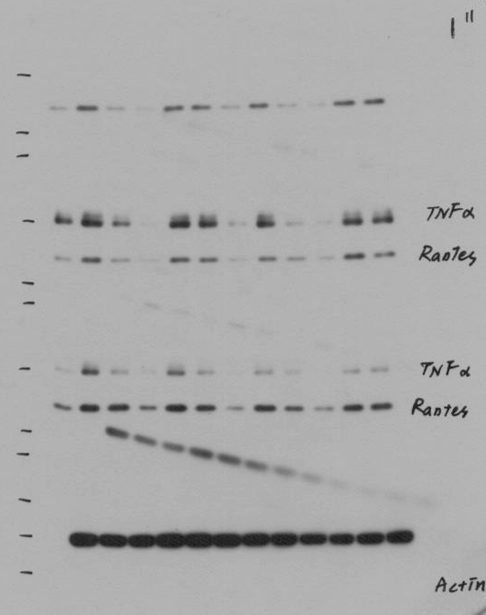
RANTES(10) & TNFa(25) & Actin-5''
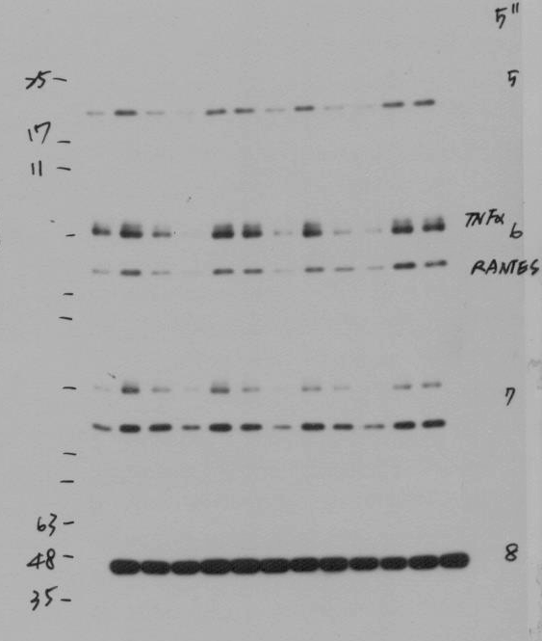
TGFb, Bax-1'
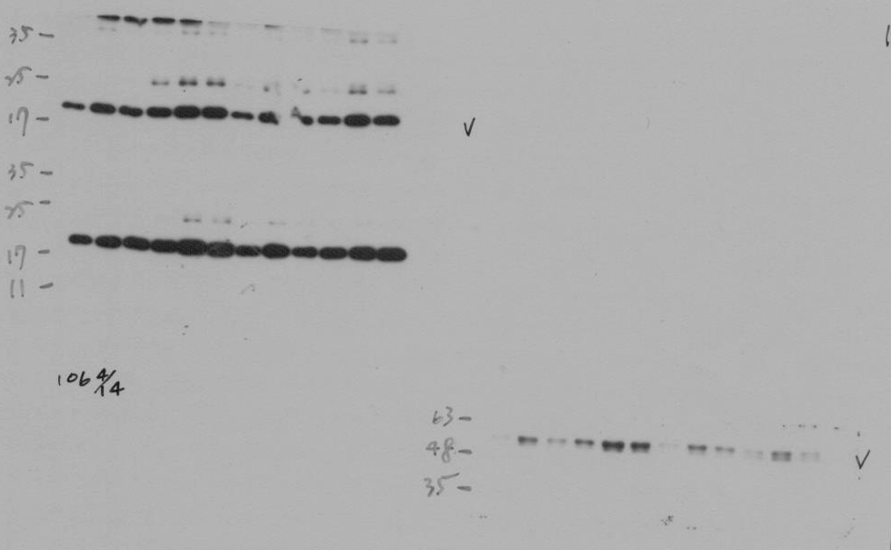
TGFb, Bax-2'
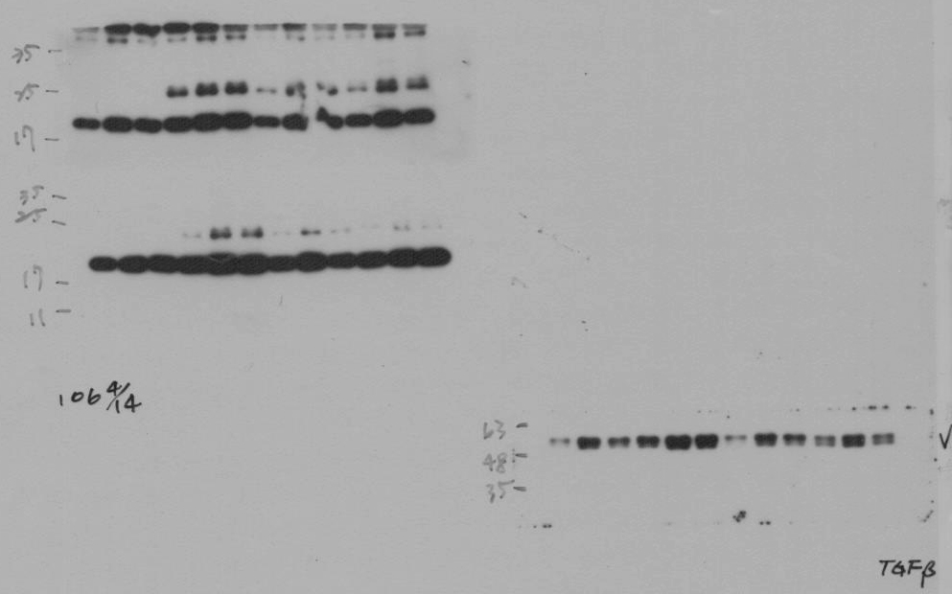
TLR2(90)-1'
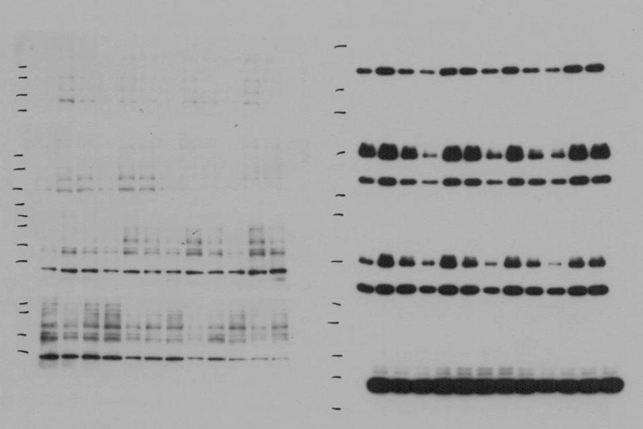
TLR2(90)-2'
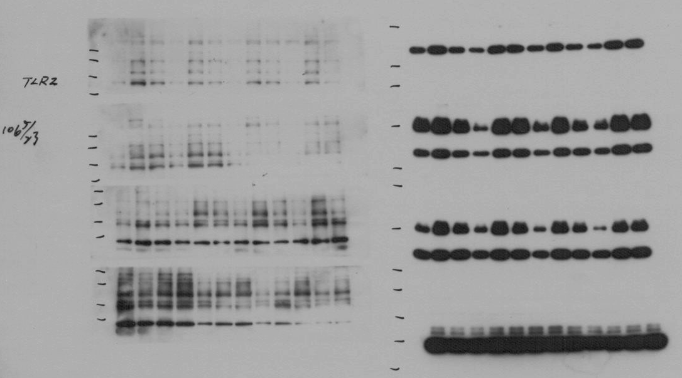
TLR2(90)-4'
