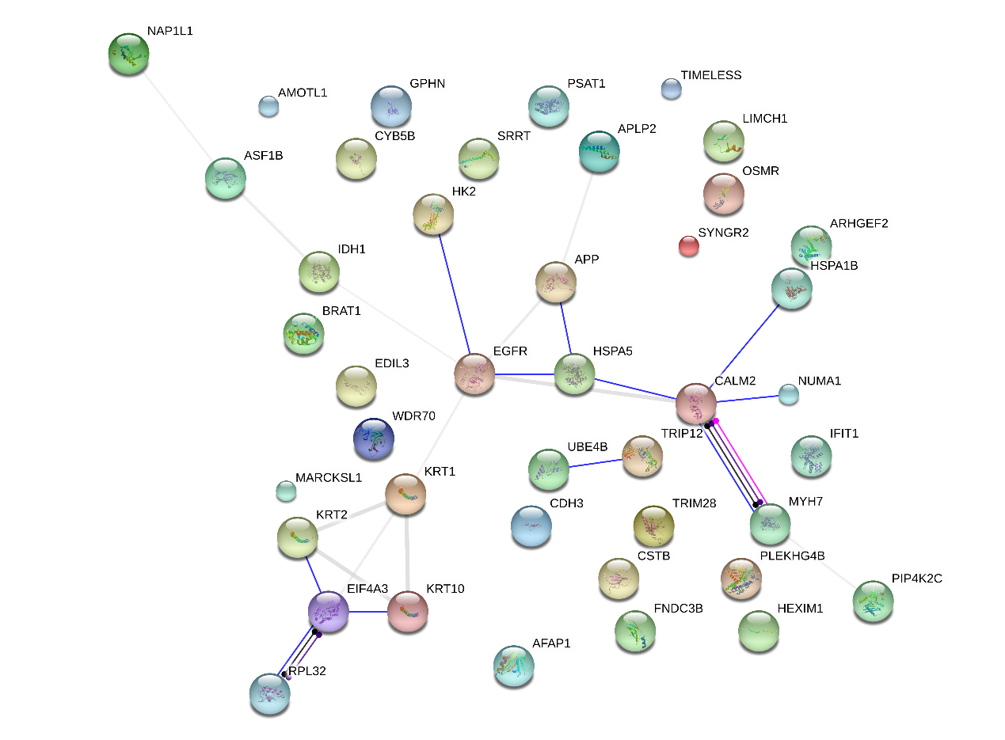The protein-protein interaction (PPI) network of the differentially expressed proteins identified in PCa DU 145 cells that analyzed by STRING 10 (Action view).

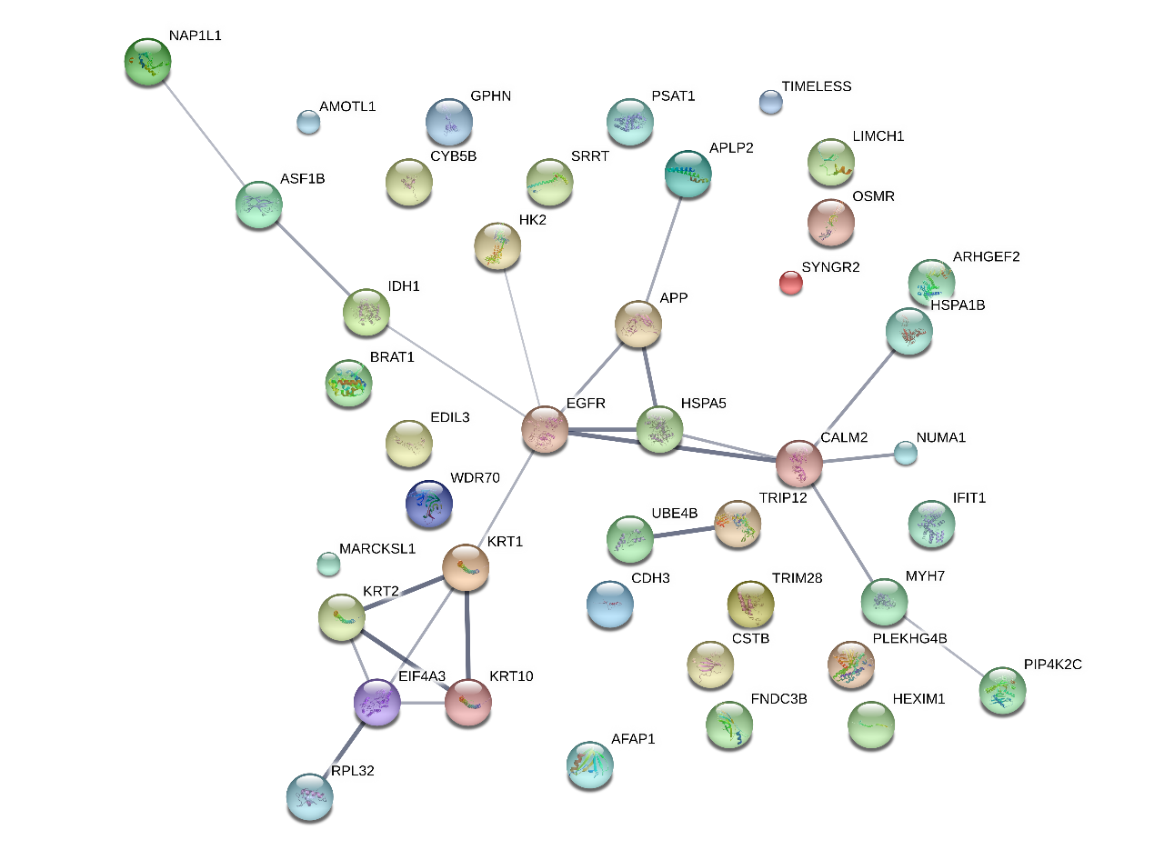
The protein-protein interaction (PPI) network of the differentially expressed proteins identified in PCa DU 145 cells that analyzed by STRING 10 (Confidence view).

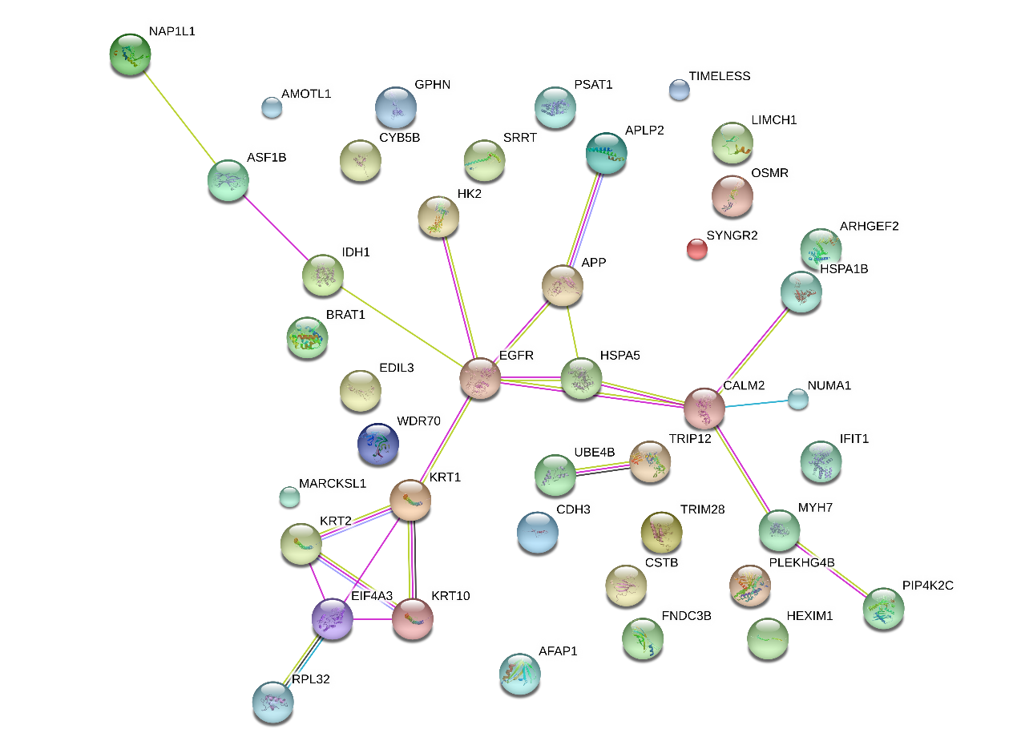
The protein-protein interaction (PPI) network of the differentially expressed proteins identified in PCa DU 145 cells that analyzed by STRING 10 (Evidence view).

